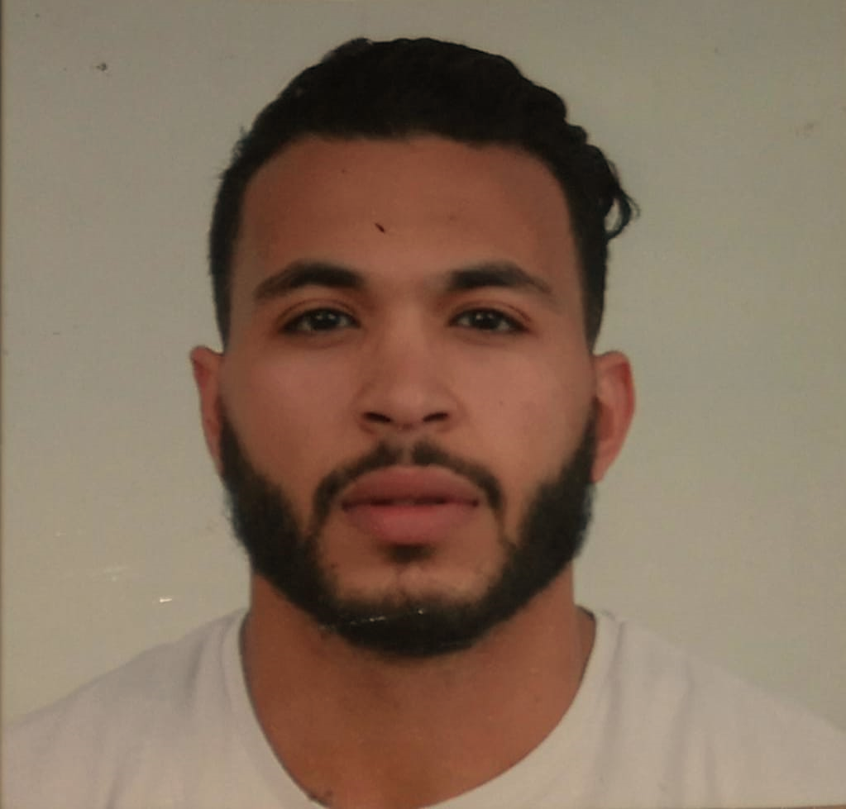 |  |  |  | Karim  Erradi Professional Fitness Coach

Experience :
January 2022 to November 2022
Fitness coach At Iron Box Gym in Saudi Arabia

August 2021 To Octobre 2021
Fitness coach At Oxygen Gym in Saudi Arabia

January 2020–2021
Fitness Coach at H2 Gym in Qatif City Saudi Arabia
January 2019–December 2019
Fitness Coach at MFitness Gym in Rabat City Morocco
6 month during 2018
Fitness Coach at Revive Gym in Rabat City Morocco
2017–2018:
Fitness Coach at City Club in Rabat City Morocco
September 2016–October 2016
Fitness Coach at Jouhari Gym in Salé City Morocco
2015:
participation in the competition « GRIANI FITNESS » 2015 MEN’S PHYSIQUE

Formation
- 2018 : Baccalaureate in Letter
- 2017: HBX diploma personal Training
- 2016: Coaching and Anatomy Diploma

Language :
- Arabic : Mother Language
- French: Intermediate
- English: Intermediate

Interest :
- Sport
- Music
- Internet
- Travel
Khafji
Avenue 25 King abdal aziz
 | 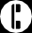 | Tel : +966 502393206  Whtp : +966 50 239 3206
 | 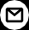 | Erradikarim4@gmail.com

